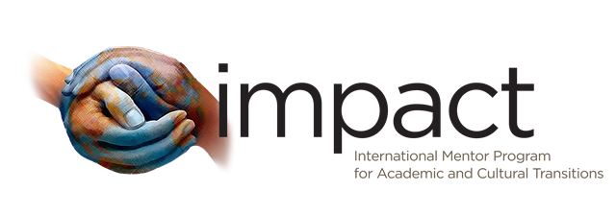

International Mentor Program for Academic and Cultural Transitions (IMPACT)
Expectations for Mentees
- Respond to initial contact from your mentor
- Meet at least once a month with your mentor
- Respond to mentors contact (e-mail, voice message, etc.) in a timely manner
- Review and sign IMPACT Contract
- Participate in OIA's IMPACT Events ( 2 events per year)
- Reach out to IMPACT coordinator at OIA to address concerns regarding the program
Communication:
Mentees are expected to respond to communication from mentors in a timely manner that is agreed upon. After the initial communication, mentees and mentors should establish the means and method of future contact, including amount of communication expected and the anticipated frequency of meetings. Structuring expectations at the beginning of the year will help mentees feel more approachable and interested and therefore more communicative.
Time Commitment:
OIA expects both mentees and mentors to actively engage with one another. The time commitment depends to some extent on the relationship established between mentor and mentee. We encourage meeting one-on-one at least once a month. These one-on-one meetings are an opportunity to get to know each other and to ensure that mentors are addressing your concerns and providing support.
Mentoring Contract:
We encourage mentees to establish a strong commitment to the program by signing IMPACT contract. This contract outlines the goals and responsibilities for mentees. The terms of the contract should be reviewed and agreed upon. The contract is a way to help encourage full program participation. Should any concerns or problems arise, mentees should contact IMPACT coordinator at OIA.
Event Participation:
OIA will sponsor two exciting events throughout the year for mentees and full participation at these events is strongly encouraged.

